# **Linux Basics**

**mkdir -p parentfolder/subfolder-1/subfolder-2**

To create tree structure directory at one shot

**rm -r <directory>**

to delete directory

**rm <filename>**

to delete filename

**touch <filename>**

to create an empty file

**nano <filename>**

to create file with an editor, cntrl+x and y to save changes

**cp <existing filename> <to filename>**

to copy a file in same location

**cp<existing filename> <directory>**

copy a file into directory

**cp -r <src folder> <tgt folder>**

copy a directory to another directory

**mv <existing filename> <new filename>**

to rename the file

**mv <filename> <directory>**

move a file into a directory

**rm <filename>**

remove a file

**more <filename>**

to read huge file

**head -<no. of lines> <filename>**

read top lines

**tail -<no. of lines> <filename>**

read bottom lines

**find . -name ‘findstring’**

find a file in the directory

**grep ‘find word’ <filename>**

**grep -i ‘find word’ <filename>**

case insensitive search

**grep -r ‘find word’ <directory>**

find in all sub directory

**wc -l <filename>**

find the no. of lines in the file

**wc <filename>**

lines, word, character

**ls -la <filename/dir>**

permissions

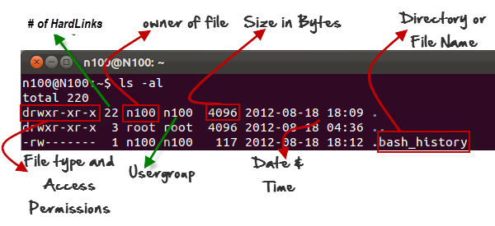

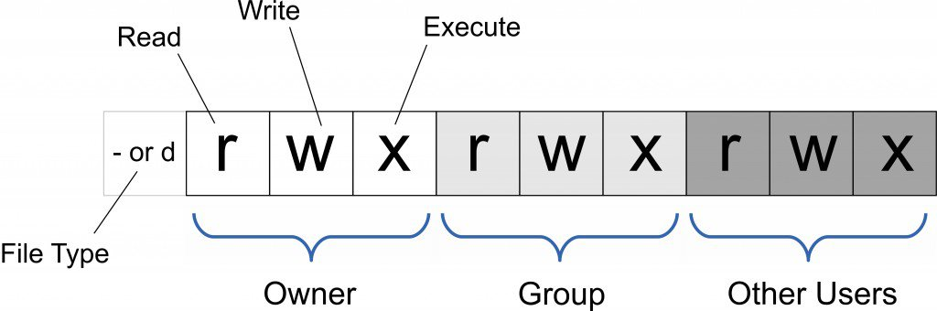

**chmod u+x <filename>**

**chmod u-w <filename>**

u (user), g (group), o(others); r (read), w(write), x (execute)

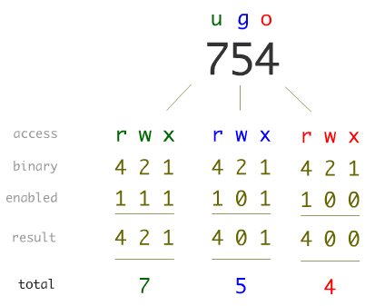

**ps aux**

To list all process running

**top**

It is list all process continuously

**kill -s KILL <pid>**

kill a particular process

**<command> &**

Want to run command in background

Put & at end

**jobs**

List the jobs running

**fg %<jobid>**

to bring job in foreground

**nohup**

run the command in background even if the session is closed

**pstree**

list of process running a parent hierarchy structure

**sample scripting**

#!/bin/bash

name=linux

echo "hello $name world"

**echo $?**

Returns last return code

nc computer_name(or ip_address) port_number

listen other computer

**nc localhost 22**

connect to local machine

**ln <original filename> <hard reference filename>**

to create multiple filenames pointing to same file – hard link, hence, if original file is deleted, reference will remain active. Cannot create hardlink to directory

**ln -s <original filename> <soft reference filename>**

to create multiple filenames pointing to same file – hard link, hence, if original file is deleted, reference will be deleted

**command1 && command2**

command 2 is executed only when command1 is successful

**command1 || command2**

command 2 is executed in any case whether command1 is successful or not

**program > <filename>**

directing the output to a file

ex: **echo ‘hello’ > hello.out**

**echo ‘world’ >> hello.out**

**command1| command2**

pipe to send the command1 o/p to command2

ex: **ls -ltr | grep ‘search word’**

Filters:

**wc -** for counting the letters, words, and lines in the input

**grep -** displays only the lines from the input in which keyword (which is passed as argument) is found.

**sort -** sorts/orders the input lines lexically (alphabetically) by default but can be changed

**more -** displays the input in a page-wise manner

**cat -** displays the content of the file passed as an argument

**sed -** substitute a word with another word: sed 's/word/another_word/'

**tr -** translate character ranges. For example to lowercase characters in input you can use:

cat /cxldata/big.txt | sed 's/ /\n/g' |more

above ex shows to replace spaces with new line and /g represent that all occurrences

cat /cxldata/big.txt |tr 'A-Z' 'a-z'| sed -E 's/[ \t]+/\n/g'|sed 's/[^0-9a-z]//g' | sort|uniq -c|sort -nr -S 50M > word_count_results_nice

**tr ‘A-Z’ ‘a-z’**

translate to lower case

**sed -E 's/[ \t]+/\n/g'**

remove spaces and tabs

**sed ‘s/[^0-9a-z]//g'**

remove non-alphamuneric character

**sort -nr**

reverse numeric sort

**sort -S 50M**

force to use specified memory only

**setuid**

program becomes an user to have special permission rather than inheriting user permission

<http://www.faqs.org/faqs/unix-faq/faq/part4/section-7.html>

chmod +sx /tmp/whoownsit_$USER.sh

**which java**

to find the location of the program

**set**

to view the environment variables